**Harvard University**

**Appendix A:**

**Procedures for Direct Charging of Administrative Salaries to Federal Awards**

**Table of Contents**

I. Introduction 3

II. Identifying Administrative or Clerical Personnel 3

III. Pre-Award/Proposal Stage Procedures 4

IV. Post-Award Procedures 5

V. GMAS Guidance 5

VI. School/Tub Level Officials 10

VII. Direct Charging of Administrative Salaries on Federal Awards Tool 11

VIII. Administrative Salary Approval Flow Chart 12

# I. Introduction

These procedures apply to federal awards. Please note it is important to review the terms and conditions of all sponsored awards to determine the specific guidelines on expenditures.

Schools/tubs may have supplemental guidance and business processes that address procedures identified in these guidelines.

# II. Identifying Administrative or Clerical Personnel

The University defines administrative and clerical personnel as providing non-technical support services that benefit departmental, institute, or center activities or objectives, including functions such as clerical support, financial management, procurement of materials and services, budget and planning, and personnel management. The salaries of administrative and clerical personnel (“admin salaries”) are normally treated as an indirect cost unless they meet the following criteria:

1. Administrative or clerical services are integral to a project or activity;
2. Individuals or specified roles involved can be identified with the project or activity; and
3. Such costs are explicitly included in the budget or have the prior written approval of the federal awarding agency.[1]

Not only does the work itself need to be that which is not normally supported by the department/local level managing unit, but the amount of administrative effort required to support the project must also be above the normal level provided. Generally, a minimum of 5% effort on training grants and a minimum of 20-25% in all other projects is suggested.

Blanket approval will not be given to a PI or department/local level managing unit; rather, the specific activities and circumstances of each award must be assessed independently to determine whether direct charging of administrative costs is justifiable.

Job codes and business titles are often too vague to fully describe the tasks performed by an individual. In each instance, the actual functions the individual performs on the project/award should be reviewed. The following titles are **examples** of jobs that have a possibility of being categorized as administrative or clerical for the purpose of this policy.

|  |  |
| --- | --- |
| **Job Description** | **Examples of Job Responsibilities that Meet Criteria** |
| Staff Assistant | NIH Institutional Center Core Grant to Support Neuroscience Research: The Administrative Core will be staffed by a half-time staff assistant who will oversee the day-to-day management of the grant. The Staff Assistant is budgeted for 50% effort in the proposal budget and his/her role is described in the budget justification. Duties include: maintaining the core web site, scheduling meetings, maintaining record or core usage and expenditures, preparing scientific reports, ordering supplies, and providing administrative support to the Core. |
| Coordinator | NSF Collaborative Research Center Grant: Full-time administrative coordinator responsible for overall operations at center including making complex travel, meeting, and visa arrangements for project collaborators or workshop participants, organizing workshops or conferences for large numbers of participants, extensive publishing of workshop materials. |
| Faculty Assistant | Extensive data accumulation, data entry, surveying, technical illustration, manuscript and publication production, and programmatic assistance with technical reporting. |

# III. Pre-Award/Proposal Stage Procedures

Once it has been determined that a proposal budget will include admin salaries, the following steps are required:

1. **The administrative role/person must be in the line-item budget and be adequately explained in the budget justification.** The budget justification should describe the situation requiring unlike circumstances, the specific duties involved, and how the normal level of administrative support provided by the department would not be adequate.
2. **The GMAS flag should be set to ‘Yes’**. When entering a proposal with a federal sponsor or prime sponsor, GMAS automatically generates the administrative salaries question. Answering ‘Yes’ will flag this for review by proposal approvers. Please see the *GMAS Guidance* Section V for detailed instructions regarding completion of data fields.
3. **The GMAS approval should be marked as ‘Done’ by the approving office.** Once the school/tub official or submitting office (depending on individual school/tub procedures) reviews the budget and justification, and the department/local level managing unit has clarified any questions, the GMAS Administrative Salaries approval status should be changed from ‘Needed’ to ‘Done’ status, and a brief comment should be added to summarize the review in order to delineate what role for which the flag was reviewed. Please see the *GMAS Guidance* Section VI for detailed instructions regarding completion of data fields. Changing this status to ‘Done’ and entering an effective date constitutes Harvard approval that the direct charging of *admin salaries with the proposed amount of effort* is allowable.

# IV. Post-Award Procedures

If an admin role is added to an award that increases the admin salary budgeted amount 10% or more or a new admin role is added for a different purpose than the original proposed and approved budget, the following steps are required **by the department/local level managing unit**:

1. Request the school/tub-level official add administrative salary to an existing project. Provide the appropriate documentation and justification that all required criteria to directly charge admin salary are met. Include the documentation that will be sent to the sponsor for approval to add admin salary as a direct cost, as required by the sponsored award. Note that NIH does not require prior approval unless additional funds are requested for such a position or the incurrence of such cost constitutes a change of scope.

1. Sponsor approval or acknowledgment should be obtained prior to updating GMAS admin salary approvals.
2. The GMAS flag should be updated accordingly once sponsor approval is confirmed. Upload documents or change comments if necessary as shown in *GMAS Guidance* Section V.

1. During quarterly or annual review by OSP Research Finance and upon request, provide written confirmation to OSP Research Finance that admin salaries are allowable and required approvals have been obtained. Admin salary charges that are not approved must be removed from the federal award to an appropriate non-federal account.

The following steps are required by **OSP Research Finance:**

1. For federal awards, OSP Research Finance conducts an annual review of award expenditures prior to filing interim and final financial reports. OSP Research Finance will follow up with the department/local level managing unit to clarify potential compliance issues related to the award expenditures, which may include the request to review and confirm that the admin salaries charged to the award are allowable and sponsor approval has been obtained from the submitting office (OSP/SPA) and from the federal sponsor as required in the sponsored award terms.
2. OSP Research Finance will obtain written confirmation from the department/local level managing unit that the admin salary charges are allowable or will remove unapproved admin salaries from the award and exclude from the financial report.
3. On a quarterly basis, OSP Research Finance will conduct sample testing of admin salaries that are directly charged to federal awards.

# V. GMAS Guidance

**GMAS Approval for Administrative Salaries at the Proposal Stage**

1. When admin salary is included in the proposal budget, in order to complete the approval attribute questions, the proposal preparer needs to select ‘Yes’ for the question of “ Are administrative salary costs included in the approvals budget (Figures A and B). Note: “Are administrative salary costs included in the approved budget” question will only appear for projects with a federal sponsor or prime federal sponsor.
2. After ‘Yes’ is selected for the “Are administrative salaries included in the approved budget?” question, the administrative costs approval will default to ‘Needed’ status. The Admin salaries approval is flagged in the Key Information section of the Initial Proposal homepage (Figure C).
3. If the preparer has additional comments or documents, they can be entered/uploaded on the approvals screen (Figure D). It is recommended that the proposal preparer should enter the proposed admin salary budget (admin roles/names and effort % if available) in the Comment field of the Admin salaries approval screen as a reference for post-award compliance monitoring of admin salaries if awarded (Figure E).
4. The proposal reviewer (either the submitting office or the school-tub level official) will review the proposed admin salaries and justification. The approval status should be changed to ‘Done’by the proposal reviewer if the appropriate approvals are in place. Only OSP/SPA has the edit privileges to change the status field to ‘Done’.

* The effective date should reflect the date the approver reviewed and discussed the salaries with the preparer.
* Comments should be entered to note the details of the approval, initials for who entered the comments, a date the comments were entered, and a brief description. They cannot be edited by department or central users.
* Documents can be uploaded by both department and central users. In addition, central users can “lock” and “unlock” documents as appropriate so that they cannot be removed or deleted from the approval repository.

**GMAS Figures**

***Figure A:*** *When creating the initial proposal,**the proposal preparer will need to answer the approval attribute questions by clicking the* ***Edit*** *button for the “Approval question have not been answered” required action from the Initial Proposal**homepage.*

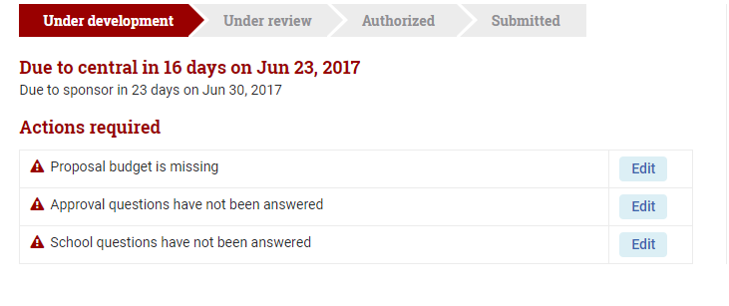

***Figure B:*** *If the proposal includes admin salaries, the proposal preparer selects ‘****Yes’*** *for the “****Are administrative salary costs Included in the approved budge****t” question in the Edit approval attributes screen.*

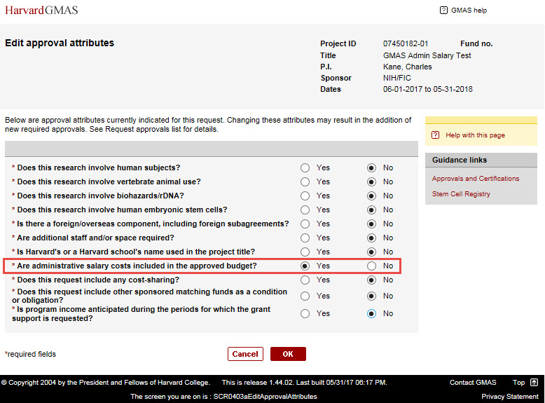

***Figure C***: *If ‘Yes’ is selected for the question of “Are administrative salary costs included in the approved budget?” in the Edit approval attributes screen. The Admin salaries approval is flagged in the Key Information section of the Initial Proposal homepage. The* ***Admin salaries approval*** *status (in the Approvals panel) will default to ‘****Needed’.***

*Note that the proposal preparer can also edit the approval attribute responses prior to locking and routing the proposal.*

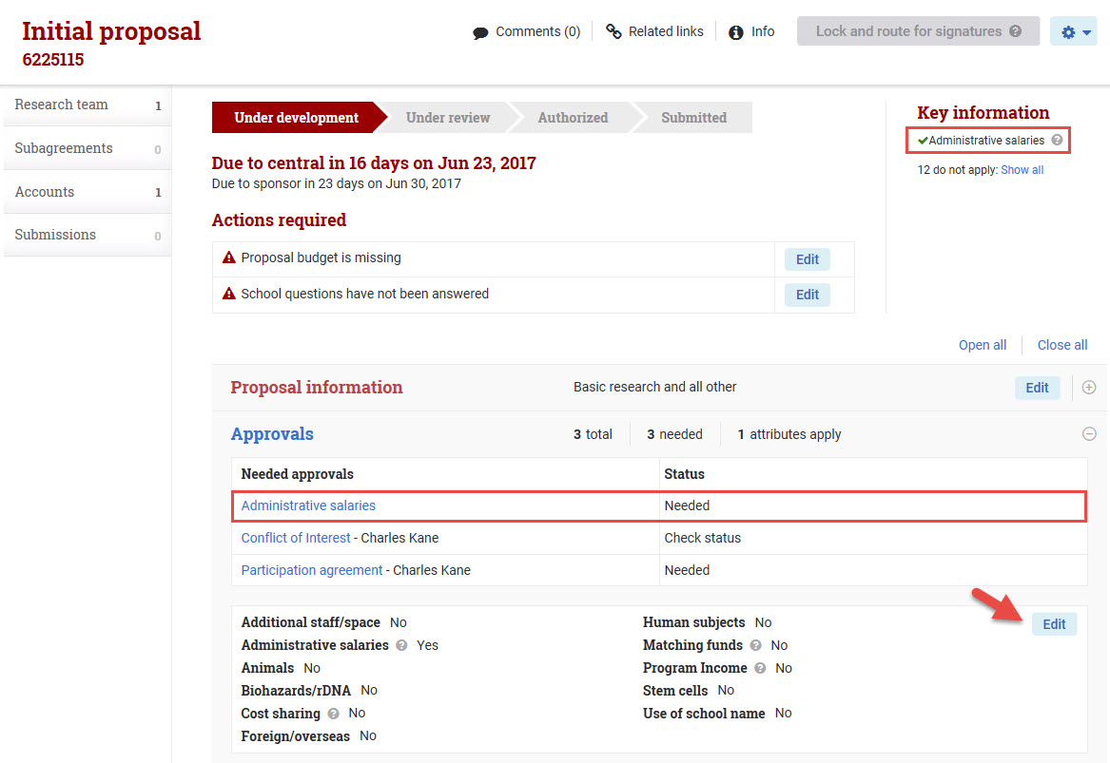

***Figure D:*** *The proposal preparer should click in the Admin salaries approval then navigate to “Admin salaries approval” screen below to add relevant documentation relating to the proposed admin salary.*

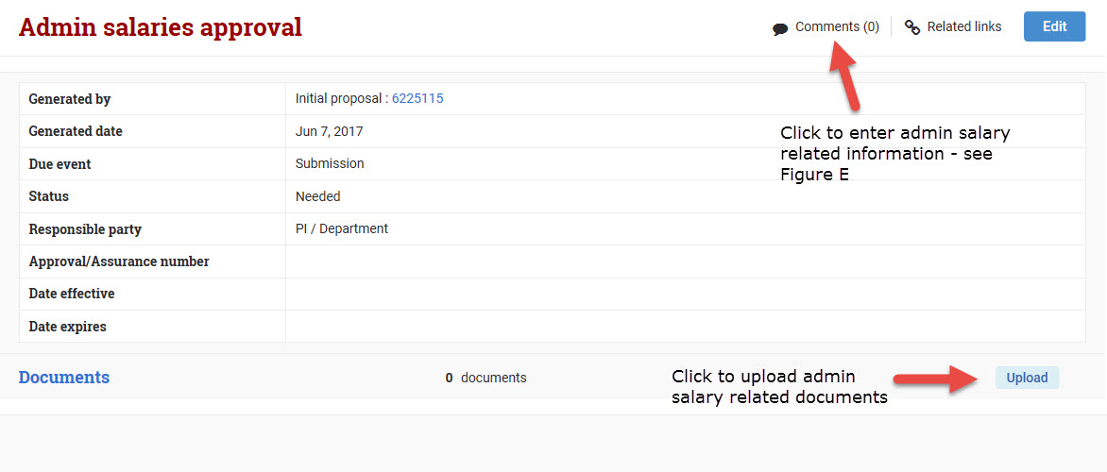

***Figure E:*** *The proposal preparer should enter the proposed admin salary budget (admin roles/names and effort % if available) in the Comment field of the Admin salaries approval screen as a reference for post-award compliance monitoring of admin salaries if awarded.*

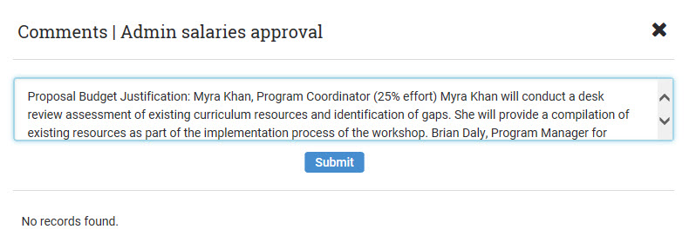

**GMAS Approval for Administrative Salaries at the Award Stage**

Once the sponsor award is received, the submitting office sets up the award in GMAS. If the sponsor has not specifically excluded the admin salaries from the awarded budget or made any other comment regarding admin salaries, sponsor approval is inferred.

* If the sponsor does not accept the admin salaries on the proposed budget, the department or responsible office must revise the budget in GMAS to reflect the sponsor approved budget. The admin salary approval question should be changed to ‘No’ by the central office.
* During the award performance, if admin salaries are no longer applicable to the project, the admin salary approval question should be changed to ‘No’ by the responsible office through a revision in GMAS.

**Note:** Once the status of the request is ‘Under review’, only the central administrator can change the flag.

**GMAS Approval for Administrative Salaries While Award is in Progress**

If admin salaries are approved after a project has been awarded, then the admin salary approval should be updated in GMAS. The admin salary and approval can be added to the award (usually through supplemental funding or a budget revision) with a GMAS request. When creating the request in GMAS, the department should answer “yes” to the admin salary question in the approval section. The central request reviewer works with the department to obtain sponsor approval and mark the admin salary approval as “Done” after review.

**A segment revision can also be used to edit the admin salary approval on an award. To request a segment revision, the department/local level managing unit should contact the central sponsored programs office (OSP, HMS-SPA, or HSPH-SPA).**

# 

# VI. School/Tub Level Officials

The following personnel/offices can provide approval and/or guidance on charging admin salaries to federal awards:

|  |  |  |
| --- | --- | --- |
| **Area** | **Office** | **Contact** |
| All Schools | Office for Sponsored Programs | [Sponsored Programs Officer](http://osp.fad.harvard.edu/content/contact-osp) |
| FAS/SEAS | Research Administration Services | Jennifer Lech (Division of Science)  Mandy Ellenwood (Social Sciences)  Jimmy Matejek (Arts & Humanities)  Pam Baker-Webber (SEAS) |
| HMS | Sponsored Programs Administration  Research Administration and Operations | HMS SPA Representative  Samantha Speyer |
| HSPH | Sponsored Programs Administration | HSPH SPA Representative  Kristie Froman |
| GSE | Sponsored Projects Office | Helen Page |
| HKS | Research Administration Office | Martha Goldberg |

# VII. Direct Charging of Administrative Salaries on Federal Awards Tool

This optional checklist may be used as an aid to ensure the appropriateness of salary charges.

**IMPORTANT REMINDER: In order to be charged directly to a federal award, administrative and clerical salaries should only be charged when they meet the definition of *unlike circumstance and are integral to the project.***

1. **Consider if the project meets any of the criteria to support administrative salaries:**

* Large, complex program such as a center or program project
* Entails assembling and managing teams of investigators from a number of institutions
* Involves extensive administrative support for data accumulation, analysis and entry, surveying, tabulation, cataloging, searching literature, and reporting (such as epidemiological studies, clinical trials, and retrospective clinical records studies)
* Requires making travel and meeting arrangements for large numbers of participants, such as conferences and seminars
* The principal focus is the preparation and production of manuals and large reports, books and monographs (excluding routine progress and technical reports)
* Is geographically inaccessible to normal departmental administrative services, such as research field sites that are remote from campus
* Requires extensive project-specific database management; extensive individualized graphics or manuscript preparation; extensive human or animal protocols
* Is a training grant

1. **When entering the administrative personnel in the proposal:**

* Ensure the staff member is on the budget when a detailed budget exists
* Explain in the justification how the project warrants that level of support to be directly charged to the grant rather than as indirect costs and explain how “unlike circumstances” are present
* Demonstrate that the level of support is greater than normal by requesting an appropriate amount of effort. Generally, a minimum of 20-25% for most projects or 5% for training grants is suggested.
* Thoroughly describe how the administrative support requested in the justification is required to meet the scientific objectives of the award
* In GMAS, answer “Yes” to the question “Are administrative salary costs included in the budget?”
* Be prepared for a discussion with your signatory about the presence of administrative salary, and to revise the justification, if needed

1. **Post Award Administration:**

* If the budget has been decreased, the school/tub and department/local level managing unit should coordinate with the submitting office to check with the sponsor to clarify if the decrease includes the administrative salary. Document this information in GMAS in the approval comments box.
* If the sponsor has denied direct charging of the staff member to the budget, school/tub, department/local level managing unit, or submitting office should document this information in GMAS in the approvals comments box. Remove any expenses that may have already been posted.
* In order for administrative salaries to be added to the budget during the course of an award, it must first be reviewed and approved by the school/tub level official.

# VIII. Administrative Salary Approval Flow Chart

The reviewer marks the approval as “*Done*,” enters the approval date in the “effective date,” and makes relevant notes in the “comments” screen in GMAS.

**Process for admin salary approval for new awards:**

1. The department enters the proposal and budget in GMAS and selects “yes” to the administrative salaries flag in the initial proposal.

2. GMAS generates an approval screen for the charging of administrative salaries. The GMAS admin costs approval defaults to “*Needed”* status.

3. The department indicates the rationale for the administrative salaries in the approvals comments and routes to approver*.

If the sponsor has not specifically excluded the administrative salaries from the awarded budget, sponsor approval is inferred.

5. The submitting office (OSP, HMS SPA or SPH SPA) reviews and approves the entire proposal and submits to the sponsor.

The reviewer marks the approval as “N/A” and notes that the “position has been removed from proposal” in the comment box. The department removes from proposal.

If the sponsor does not accept the admin salaries on the proposed budget, the department must revise the budget in GMAS to reflect the sponsor approved budget.

4. The pre-award office and/or school-level research administration office reviews the admin salary request and determines if the need is sufficiently documented.

NO

School Approval

YES

NO

Sponsor Approval

YES

*The approver may be the school-level research administration office, HMS Sponsored Programs Administration, SPH Sponsored Programs Administration, FAS Research Administration Services, or OSP, depending on individual school procedure.

**Process for adding approved admin salary to an existing award in progress:**

1. The department works with the submitting office to obtain written sponsor approval to add admin salaries to the awarded budget.

3. The department revises the admin salary approval attribute as part of the request (if not already revised with the budget revision).

2. The submitting office provides guidance on the appropriate GMAS action (either revision or request) to flag the award for admin salary.

4. OSP/SPA changes the admin approval to ‘Done’ after sponsor approval and central review.

1. Note that agency approval requirements may vary. Please refer to the agency requirements and sponsored award terms. For example, NIH states “prior approval is not required unless additional funds are requested for such a position or the incurrence of such cost constitutes a change of scope”.