|  |
| --- |
| eCOMS PI Quick Reference Guide |

**May 2014**

Version 1.0

Table of Contents

Logging In 3

Automatically Logging In 3

Creating a New COMS Study 4

Understanding Help Text 4

Editing a COMS Study 7

Checking the COMS Study for Errors 8

Submitting the COMS Study 9

What to Expect After Submitting 10

Changing the PI Designee 11

Accessing a COMS Study 12

Responding to changes requested by COMS 13

Adding/Changing Documents on Your COMS Study 15

Submitting Amendments, Renewals and Closing your COMS Study 16

Checklist of Information to Attach for Clinical Trial Studies 17

Resources and Support 17

Logging In

eCOMS system is secure, which means only authorized individuals have access to it. When you log in to the system, you get a personalized view of the information and possible actions pertinent to you.

|  |  |
| --- | --- |
| To log in:   1. Click on e-COMS link: <https://esupport.hms.harvard.edu/COMSIACUC/> 2. If you have difficulty with your browser, please review: [Supported Browsers](https://techpubs.clickcommerce.com/ckn/#Knowledgebase/Supported_Web_Browsers.htm%3FTocPath%3DKnowledge%20Base%20Articles%7C_____66) 3. If you do not see the form shown to the right, click the Login link located at the top right corner of your screen. 4. BasicLoginType the user name and password you received into  the boxes. |  |
| Tips: Press the Tab key after typing your user name to move to the Password box.  If you do not know your user name or password, contact eSupport. (See Resources and Support on page 17.)   1. Click Login (or press Enter). | |

Automatically Logging In

You can set the system to log you in automatically when you access eCOMS.

Important! Do not enable autologin if you are using a shared or public computer. Autologin could cause a security breach by allowing others to take actions as though they were you.

|  |  |
| --- | --- |
| To turn on autologin:   1. The next time you log in, check the Remember me box before clicking Login. |  |
|  |  |
| To turn off autologin:   1. Click the Logoff link in the upper right corner. 2. Click Clear Autologin. |  |

Creating a New COMS Study

You can prepare a new COMS Study for COMS review by entering information into a series of online forms. The number of forms included may change based on the answers you provide. The forms tell you where to attach files to provide supporting information.

The simplest approach is to follow the forms in order, answering the questions and clicking Continue to ave your information and move to the next form. When you reach the end of the series of forms, click the Finish button.

Before you begin, gather files and information about your COMS Study such as:

* Supporting information files (for a list, see **Checklist of Information to Attach** on page 17)
* COMS registration information for related research to your COMS Study

To create a new COMS Study for review:

1. From My Inbox, click New COMS Study.



Note: If you do not see the New COMS Study button, click the My Home link (upper right).



1. Fill in the applicable boxes and answer the questions.
2. Click Continue to move to the next form.

Tip: A red asterisk (*) precedes each question that requires an answer. If you cannot answer a required question at this time, or if you need to stop and continue at a later time, click the save button and exit the document. Alternatively you can use the “jump to” button to move ahead to the next section of the form. If you do not answer a required question initially, you must return and answer it before you can submit the COMS Study for review.

1. When you reach the final page, click Finish to exit the COMS Study.

You can continue to edit the COMS Study until you submit it for review. See Editing a COMS Study on page 7.

Important! The COMS Study has not been submitted for review yet. For instructions, see Submitting the COMS Study for Review on page 9.

Understanding Help Text

| To find this... | ...look for this... | ...and click... |
| --- | --- | --- |
| More information about a question or form. | HoverHelp | The question mark icon next to the question or form title. |

**Including Study Staff in the COMS Study**

On the **General Information** page, study staff may be easily added into the study by typing their name into the box provided.The system will autopopulate the names of staff with HUIDs. Manually enter the first and last names of study staff without HUIDs. Finally, enter the study staff in the corresponding field for staff that are to be notified as emergency contacts.

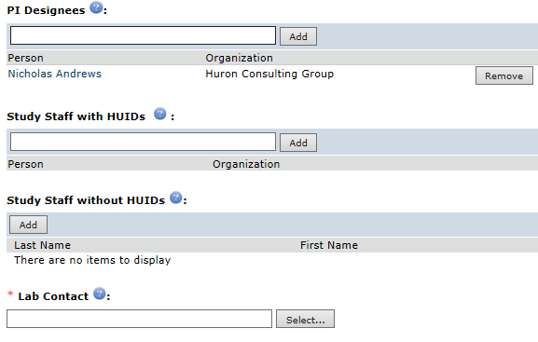

**Providing Address Information in your COMS Study**

In the **Address Information** page, list the mailing address of your research by entering the institution and research building. This information will help route your study to the correct biosafety officer for review.

Additionally, please indicate which department the investigator belongs to in the Department field.

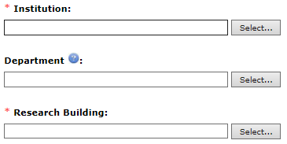

**Including Related Research in your COMS Study**

If collaborators are individually registering work that falls under the same project, please list those registrations here.

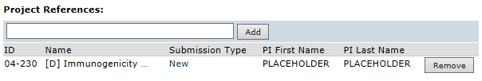

**Hazard disclosure in your COMS Study**

On the **Hazard Identification** page, eCOMS will ask a series of questions about the materials in your study. By indicating “yes” you will be provided follow-up questions about those materials. By indicating “no” you will not be asked further about these materials. Providing this information will also inform your biosafety officer about the materials so that a proper risk assessment of the hazards can be completed.

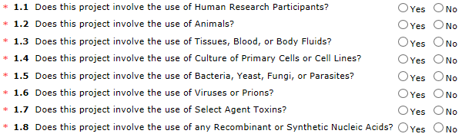

Editing a COMS Study

You can continue to make changes to a COMS Study until you submit it for review. You can also make changes if your biosafety officer requests clarifications or modifications.

To edit a COMS Study:

1. From My Inbox, click the name of the COMS Study to open it.

Note: If the COMS Study does not appear in your inbox, see **Accessing a COMS Study** on page 12.

1. Click Edit Project on the left.

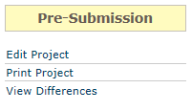

1. Make changes as appropriate.
2. Exit the COMS Study.

Tip: Choose one of these ways to exit:

* + Click the Exit link.



If prompted to save the COMS Study, click Yes.

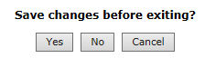

* + Click Continue on each page, and then click the Finish button on the **Finish** page.



Checking the COMS Study for Errors

Checking the COMS Study for errors and omissions helps you include all the relevant information, which is critical for receiving a timely review of your COMS Study.

Using these types of error checking helps you supply all the information COMS needs:

* Automatic system error checking identifies any omitted answers to required questions on the form when you click Continue. A red asterisk (*) precedes each blank or question that requires an answer.
* Page level error checking identifies pages where at least one field should have an entry based on your answer to a question previously listed in the form.
* Visually inspecting the forms to see what you may have missed, especially:
  + Questions that are relevant to your COMS Study but are not required for all studies.

To perform a visual inspection, open the COMS Study and look through the forms in order. To open the COMS Study, see Editing a COMS Study on page 7.

* Using the Hide/Show Errors option to find and correct all errors before submitting the COMS Study. The system automatically checks for errors when the PI attempts to submit the COMS Study. However, if you are filling out the forms on behalf of the PI, it is best to check the COMS Study for errors before the PI attempts to submit it, using the steps below.

To use Hide/Show Errors to find and correct errors:

1. Location of Hide/Show Errors optionOpen the COMS Study, as explained in Editing a COMS Study on page 7.
2. From the top navigation area, click Hide/Show Errors.

The Error/Warning Messages pane appears at the bottom of the window, listing all the current errors and where to find them.

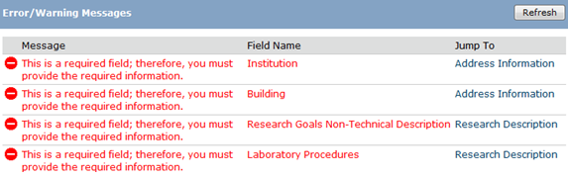

1. For one of the errors listed, click the link in the Jump To column to go to the page containing   
   the error.
2. Click Continue to identify the specific questions on the form with errors.
3. Fill in the missing information.
4. Click Refresh in the Error/Warning Messages pane to update the list of errors.
5. Continue correcting errors until no errors are listed.

Submitting the COMS Study

After entering all required information into the forms and attaching files, the principal investigator must submit the COMS Study.

Tips:

* Make sure you attach all applicable information to the COMS Study, as identified in Checklist of Information to Attach on page 17
* Check for missing information before attempting to submit the COMS Study, as described in Checking the COMS Study for Errors on page 8. Any errors or omissions not corrected are shown when attempting to submit the COMS Study and must be corrected before you can submit it.

To submit the COMS Study:

Important! **Only the Principal Investigator** can complete the following steps.

1. Log in to the system.
2. Make sure you are in My Inbox. (Click the My Inbox link - top right part of the page)
3. Click the name of the COMS Study to open it.

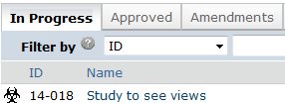

Tip: If the COMS Study does not appear in the list, perhaps it was already submitted, or it does not include you as a COMS Study team member. To find the COMS Study, try clicking COMS in the top left navigation area.



If you do not see it in that list, see Accessing a COMS Study on page 12 for more ideas.

1. Click Submit New Study from the My Current Actions list on the left.

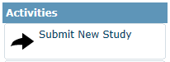

Tip: If any errors or warnings are shown, click the link in the Jump To column to go to the form containing the problem. For more information, see Checking the COMS Study for Errors on page 8. When all errors are corrected, try submitting the COMS Study by clicking **Submit New Study** again.

1. Click OK to agree to the statement presented on the screen.
2. Click Submit.

What to Expect After Submitting

Submitting information to COMS initiates a series of activities that may include:

* Review by your Institutional Biosafety Officer
* Pre-review by a COMS staff member
* Possible review by an appointed COMS committee member (pre-meeting)
* Review by the COMS committee
* Communication of COMS decision to the PI

Any of these may lead to a request for the PI to take further action, such as providing clarifications or modifying the COMS Study.

Whenever you need to act, you receive an e-mail notification, and the COMS Study appears in My Inbox when you log in to COMS system.

Important! Make sure the appropriate person is listed as the PI Designee to receive the e-mail and see the COMS Study in My Inbox (along with the PI, who always receives these). See **Changing the Designee** on page 11.

You can easily access your COMS Study from one of the following areas within the COMS tab:

* In Progress
* Approved
* Amendments
* Archived

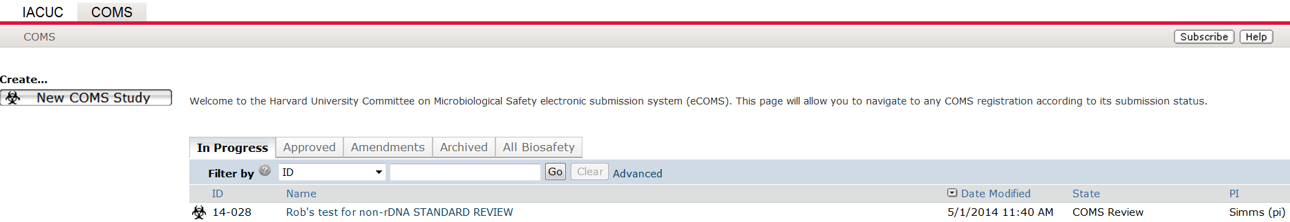

For instructions about opening your COMS Study from these lists, see **Accessing a COMS Study** on page 12.

Changing the PI Designee

The COMS Study's PI designee can be changed at any time.

Notes:

* To change the PI designee, you must be the PI.
* The PI continues to receive notifications regardless of the PI designee assignment.
* By default, Amendments and Renewals have the same PI designee as the initial COMS Study. To change the PI designee on these submissions. You can update the designee in the Amendment SmartForm and on the Annual Renewal activity view.

To change the PI designee:

1. Open the COMS Study by clicking the COMS Study's name. (For instructions about finding the COMS Study, see Accessing a COMS Study on page 12.)
2. Click **Edit Project** from the list on the left. The project will open.

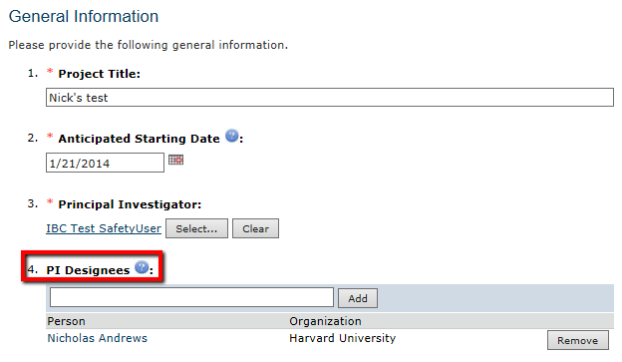

1. Click Remove to remove the current designee.
2. Enter the name of the new designee.
3. Select the user.

Note: If the PI designee is also engaged in the research, make sure the **Study Staff** within the COMS Study includes this individual.

Accessing a COMS Study

You may want to open a specific COMS Study to view or update its contents, review, submit, or take other actions on the COMS Study.

Note: Your access to a COMS Study is personalized based on your role in the system and the role you play in relation to the particular COMS Study. In addition, the actions you can take on a COMS Study are personalized.

To open a COMS Study, click its name when you find it in a list of studies.

To find a list that includes all COMS Studies, try these suggestions:

| Check this list... | For... | How to find this list |
| --- | --- | --- |
| **In Progress tab** | COMS studies that are in the process of being reviewed  This includes studies going through their initial review and studies that have had amendments submitted for review by COMS | Click the COMS tab link in the top of the page    Click the **In Progress tab** located within the COMS tab |
| **Approved tab** | Your studies that have been approved can be found here |  |
| **Amendments tab** | Amendments made to your study can be found here. These amendments are SEPARATE from originally submitted studies. They exist as a separate submission until approved, then overwrite the original study. Even when approved, they still exist as separate entities and can be found here. |  |
| **Archived tab** | Your inactive, withdrawn and rejected studies can be found here |  |
| **All Biosafety tab** | All studies registered in the system that you have permission to view | Tip: Try filtering this list by the COMS Study name or principal investigator. Next to Filter by, select Name or **PI**. Then type the beginning of the name and click Go |

Responding to changes requested by COMS

At any stage during the review process, COMS may request clarifications to the COMS Study content. You will receive these requests through your institutional biosafety officer. Similarly, the official COMS determination may be that the COMS Study requires changes before research can begin.

Both situations require the PI for a COMS Study to take similar actions. In either case, the PI or PI designee receive an e-mail to review the COMS Study in My Inbox.

Important! Failure to respond promptly slows the review and approval process for your submission. In some cases, your submission may be rescheduled for review at a later COMS meeting because the committee requires your response before making a decision.

To view the details of the request and respond with the changes:

1. From My Inbox, click the name of the COMS Study to open it.
2. Locate the details of the request, as described here:

For COMS questions requiring a response, you may find reviewer notes logged. Reviewer Notes exist at the top of each SmartForm page and can be accessed by clicking a small arrow to the left.

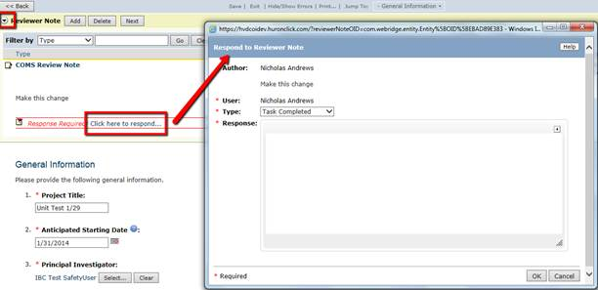

1. Edit the COMS Study to incorporate changes as needed. For instructions, see Editing a COMS Study on page 7.

Notes:

* + In most cases, you can update all aspects of the COMS Study, including adding, updating, or removing attached documents.
  + When updating a COMS Study document previously submitted to COMS, revise it in tracked-changes format and replace the original document with the tracked-changes version. When COMS approves the document, all tracked changes will be accepted and comments removed in the final version.

1. Click Submit Changes to return the COMS Study to the institutional biosafety officer.

Notes:

* + The Submit Changes form gives you space to type a point-by-point response to the requests and to attach a file. However, any permanent Study information should be incorporated into the COMS Study itself.
  + If clarifications were requested during committee review, you may be asked to make changes to the COMS Study after the review is complete.

1. Click OK.

The COMS Study returns to the review process.

Adding/Changing Documents on Your COMS Study

You may need to modify a COMS Study's documents when:

* COMS require changes prior to approval.
* Submitting an amendment to an approved COMS Study.

To add/change documents prior to COMS Study approval:

Note: These steps apply if your institutional biosafety officer contacts you about making changes. This could be in cases when a COMS decision was approved with stipulations, rejected or deferred.

1. From My Inbox, click the name of the COMS Study to open it.
2. Click the **Add Supporting** Documents tab.

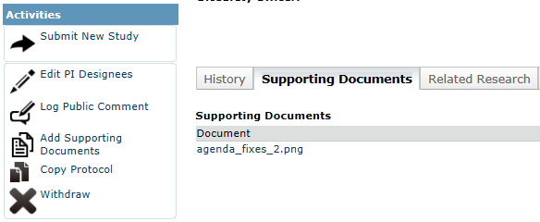

1. Click the document in the Draft column and save it to your computer.
2. Open the document.
3. Enable the Track Changes feature and update the document.
4. When finished, replace the original COMS Study document with the tracked-changes version.

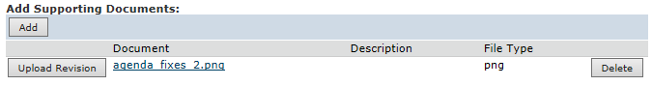

Submitting Amendments, Renewals and Closing your COMS Study

The table below summarizes how to get started submitting each type of information to COMS.

| To submit this type of information... | ...start here... | ...and click this button | Notes |
| --- | --- | --- | --- |
| Amendments for an active COMS Study | For new information about a particular COMS Study, start from the Approved tab and click the COMS Study name (see Accessing a COMS Study on page 12) |  | Submittal of an amendment form prompts you to identify the type of information to submit. PI may submit an administrative amendment for personnel related updates or a scientific update for research changes. Administrative updates are immediately approved and are not sent to full committee. Report new information as soon as you become aware of it. The form identifies the types of information you must report. |
| Annual Renewal | Submit Annual Renewal |  | eCOMS will send automatic notification to renew Reminder Notifications trigger 90, 60, 30,10 days from renewal date  every 12 months. |
| Protocol Closure | Request inactivation |  | Report COMS study closures to eCOMS as well as to your institutional biosafety officer |
| Updates to a  new COMS Study that has not been submitted to COMS | Within the COMS Study (see Accessing a COMS Study on page 12) |  | See Editing a COMS Study on page 7 |

Checklist of Information to Attach for Clinical Trial Studies

Be prepared to attach several files to your COMS Study. While editing the COMS Study, several forms provide places to attach related files. In some cases, a template file is provided, such as for the protocol.

When attaching each file, name it as you want it to appear on COMS approval letter.

Attach the information listed below (if relevant to your COMS Study) to the location identified.

| **Clinical Protocol:** (**Basic Information** page) | |
| --- | --- |
| * Research Protocol * Investigators Brochure * Informed Consent * IRB approval |  |
| Additional Information for Gene Therapy Clinical Trial: | |
| * Appendix M * RAC Review * PI CV | * Other relevant information may be included such as:   Verification of each IND number (one of these):   * + Sponsor protocol with the IND number   + Communication from the FDA or sponsor with the IND number   + IRB approval |

Resources and Support

For additional answers to your questions, feel free to use the following resources:

| Resource | How to access it |
| --- | --- |
| Documentation | See Finding More Information on page 6 |
| Online Training Materials | <http://hms.harvard.edu/departments/committee-microbiological-safety> |
| COMS Support staff | E-mail: coms@hms.harvard.edu  Phone: 617-432-4897 |
| e-COMS Support | [esupport@hms.harvard.edu](mailto:esupport@hms.harvard.edu) |