NEW CONCUR USER INTERFACE

OVERVIEW
Harvard will be transitioning to a new Concur User Interface (NextGen UI) with new features and enhancements including an accessible design for all users. This new User Interface will replace the existing, Legacy User Interface currently used.
Why: The existing User Interface will be decommissioned by Concur in the fall of 2022.

Who: All Faculty and Staff who use Concur to process reimbursements.

What: NextGen UI is the continued evolution of Concur Expense end user experience. A more intuitive experience that guides users where to go, reducing errors
The Mobile App and Approver view and functionality have not changed!
When: March 28,2022

CHANGES

Expense Details and Receipt available in One View (Side by Side)
- Hotel Itemization
- Adding Meal Attendees
- Allocations
- Adding Documents at the Report Header
- “Approval Flow” is now called “Report Timeline”
- “Missing Receipt Affidavit” is now referred to as “Missing Receipt Declaration”
- Delegates can “pull back” a report by selecting “Not Ready For Review” if the report has not been “Submitted” but the employee

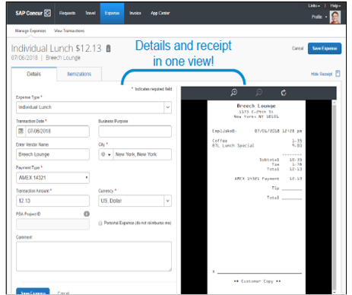
Expense Details and receipt available in One View
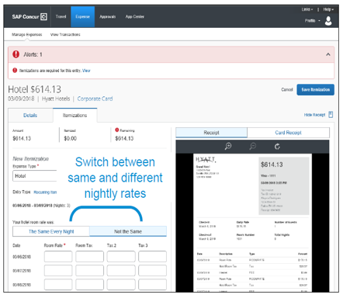
Easier Hotel Itemization Screen
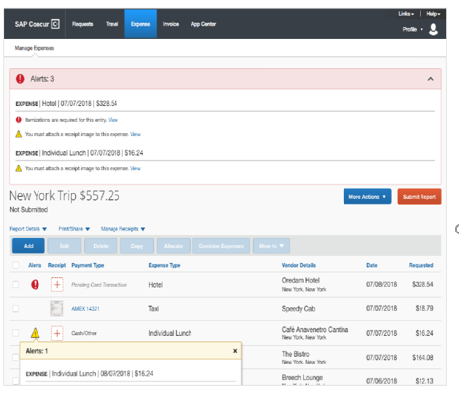
Clean design focused on guiding users to Next Step

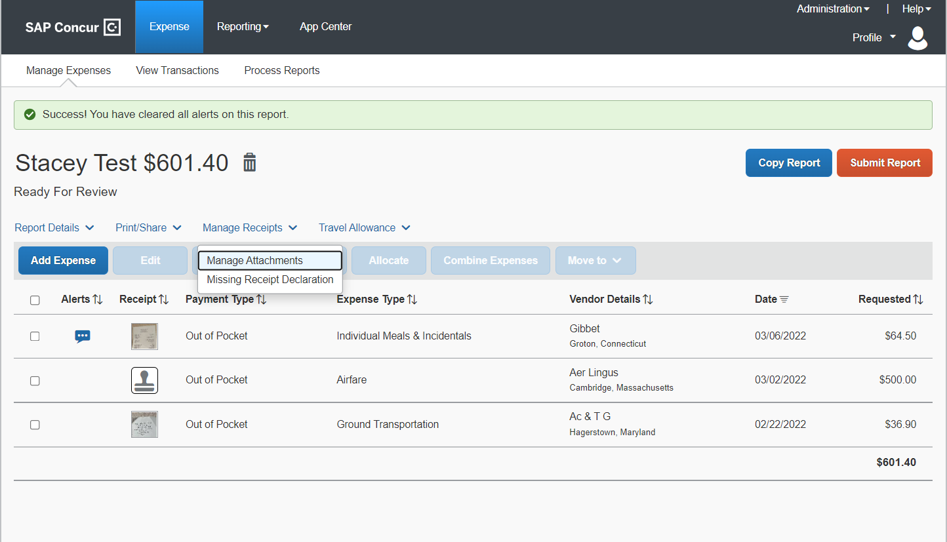
Reimbursees can review reports ready for submission by selecting Print Share for report summary.
Receipts can be reviewed by selecting Manage Receipts > Manage Attachments

RESOURCES
Updated training materials can be found on the Concur Website -Concur Training
Concur office Hours: Monday & Wednesday’s 11AM-12PM beginning 3/28/22 – see Concur Website for Zoom link

